**EXPERIMENT 2**

**Name: Vrinda Gupta**

**SAP- 500109760**

**Batch- B2 devops**

**AIM: Working with Docker (Basic Commands)**

**Steps to Complete**

1. Search a Redis image on DockerHub

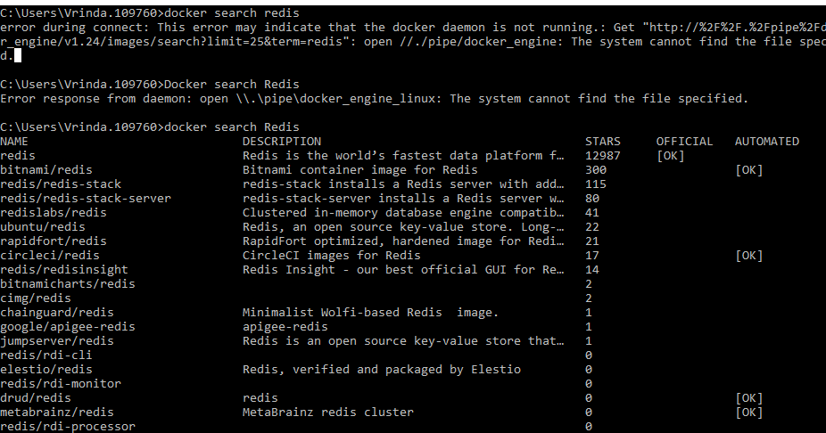

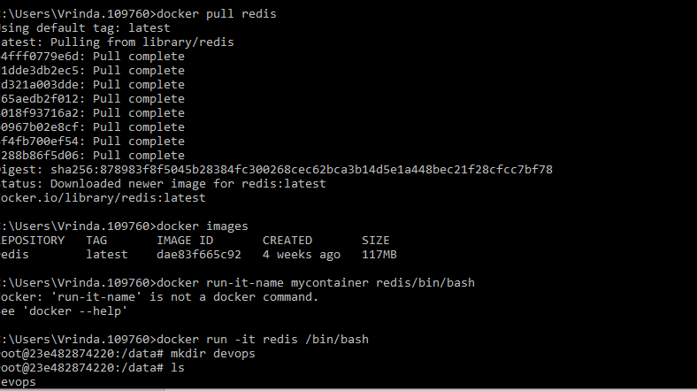

1. Run Docker Container of Redis Image in background

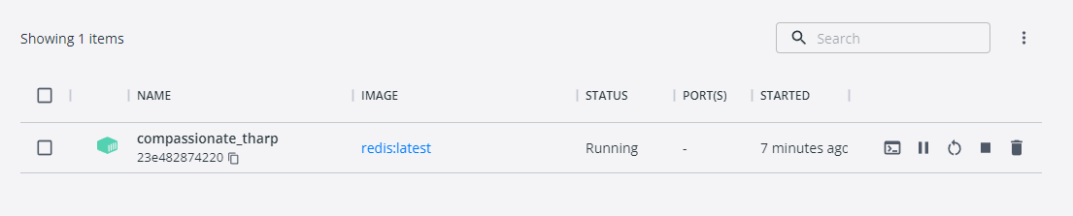

1. Run Docker PS and Docker PS –a

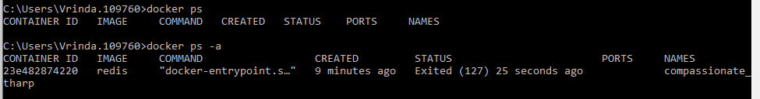

1. Run Docker Container and take its console

